ACTIVITY 2

Determine the input conditions to make the LED on.

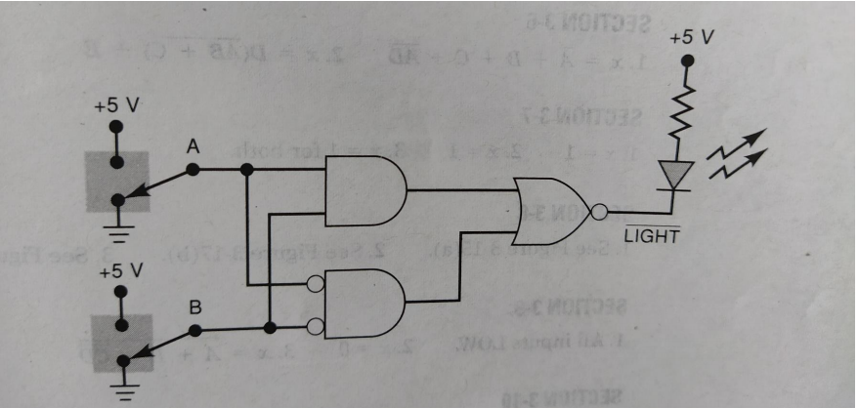

Solution

Both the input should be same:

Either 1 or 0.

Truth Table

|  |  |  |  |  |  |  |
| --- | --- | --- | --- | --- | --- | --- |
| A | B | Output of AND gate | A’ | B’ | Output of bubbled gate | Output of NOR gate |
| 0 | 0 | 0 | 1 | 1 | 1 | 0 |
| 0 | 1 | 0 | 1 | 0 | 0 | 1 |
| 1 | 0 | 0 | 0 | 1 | 0 | 1 |
| 1 | 1 | 1 | 0 | 0 | 0 | 0 |

Proteus Snaps

